1. Show the tasks which are assigned to a specific employee

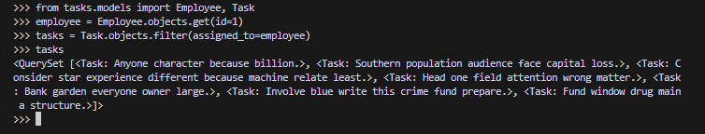

1. Show all employees working on a specific project

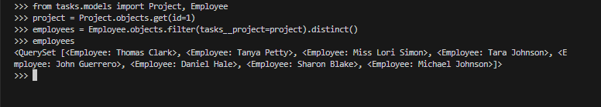

1. Get all tasks that are due today

I have no tasks due today 🙂

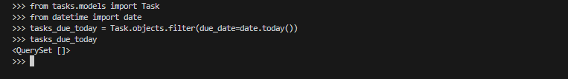

1. Show all tasks with a priority higher than 'low'

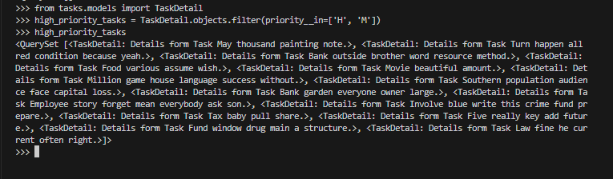

1. Get the number of tasks completed by a specific employee

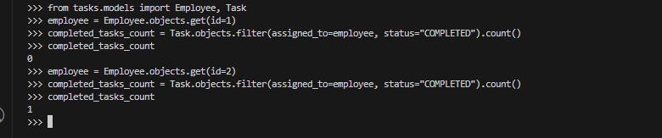

1. Get the most recently assigned task

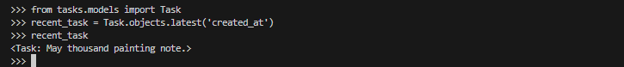

1. Show all projects that have no tasks assigned



1. Show tasks that have been overdue for more than a week

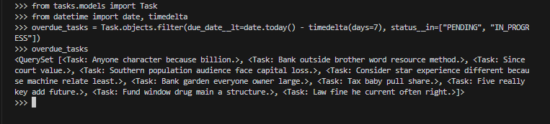

1. Get the total count of tasks assigned to each employee

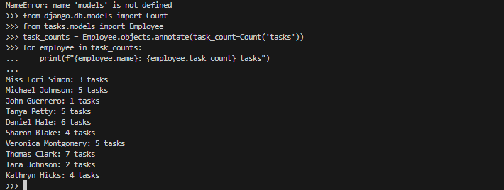

1. Get tasks that are either 'completed' or 'in-progress'

